
Nambucca Shire Council

Planning Proposal
Nambucca Local Environmental Plan
Amendment No. 24

RECLASSIFICATION AND REZONING OF LOT 45 DP 228703, 99-101 OCEAN VIEW DRIVE, VALLA BEACH

Prepared by:
Development & Environment Section
Nambucca Shire Council

Dated: July 2019

File:SF600
TABLE OF CONTENTS

Preliminary 1
Part 1 Objectives and Intended outcomes 1
Part 2 Explanation of Provisions 1
Part 3 Justification 2
Section A – Need for the Planning Proposal 2
Section B –Relationship to strategic planning framework. 2
Section C – Environmental, social and economic impact 10
Section D – State and Commonwealth Interests 13
Part 4 Mapping 13
Part 5 Community Consultation 13
Part 6 Project Timeline 14
AttachmentS 14

Preliminary

This planning proposal has been drafted in accordance with Section 3.33 of the Environmental Planning and Assessment Act 1979, and ‘A guide to preparing planning proposals’ (DoP, 2016) for amendment to the Nambucca Local Environmental Plan 2010 (LEP). A gateway determination under Section 3.34 of the Act is requested.

This planning proposal relates to part lot 45 DP228703 99-101 Ocean view Drive Valla Beach. For the purposes of this Planning Proposal the following applies:

- ‘The Lot’ refers to the entire of Lot 45 DP228703; and
- ‘The Subject Land’ refers to the portion of Lot 45 DP228703 proposed to be reclassified as part of this proposal.

The Lot is presently Council owned and managed land which is 1.8HA in size. The Lot is presently classified as community land and categorised as Natural Area – Bushland.

This planning proposal has been prepared to reclassify the subject land from community to operational categorisation in order to allow for its future disposal. Section 27 of the Local Government Act 1993 provides that a Council can only reclassify community land as operational land via a local environmental plan.

Attachment 1 shows the Lot, the proposed reclassification of part of the subject land from community land to operational land. The subject land has an area of approximately 1,300m².

An access handle approximately 7m in width is proposed to be retained to allow firefighting and council vehicles to obtain access to the bushland located at the rear and behind No’s 89 to 119 Ocean View Drive.

There is an opportunity to provide a linking fire trail along the rear of the properties between 103 Ocean View Drive and 119 Ocean View Drive should the commissioner of NSW Rural Fire Service deem it appropriate. Alternatively residents could be provided with a right through an easement to undertake hazard reduction in the reserve immediately at the rear of their properties

Part 1 Objectives and Intended outcomes

The objectives and intended outcomes of this planning proposal are to:

- Reclassify Part Lot 45 DP228703 (99-101 Ocean View Drive Valla Beach) from community land to operational land to allow for its future disposal;

- Rezone Part Lot 45 DP228703 (99-101 Ocean View Drive Valla Beach) from RE1 Public Recreation to R1 General Residential to allow for future residential development;

- Amend the Height of Buildings map on Part Lot 45 DP228703 (99-101 Ocean View Drive Valla Beach) to incorporate a 8.5m Height Limit consistent with surrounding residential land;

- Amend the Floor Space Ratio on Part Lot 45 DP228703 (99-101 Ocean View Drive Valla Beach) to incorporate a floor space ratio of 0.55:1 consistent with surrounding residential land;

- Amend the minimum Lot Size on Part Lot 45 DP228703 (99-101 Ocean View Drive Valla Beach) to a minimum lot size of 450m² consistent with surrounding residential land.

Part 2 Explanation of Provisions

The proposed outcomes will be achieved (in numerical order as identified above) by:

- Amending Schedule 4 Classification and reclassification of Public Land Part 2 Land Classified or reclassified as operational – interests changed to include Part Lot 45 DP228703 (99-101 Ocean View Drive Valla Beach). The relevant part of Lot 45 DP228703 will be identified on the Land Reclassification (Part Lots) Map as shown in attachment 1;

- Amending the Land Zoning Map for Part Lot 45 DP228703 (99-101 Ocean View Drive Valla Beach) to R1 General Residential as shown in attachment 1;

- Amending the Floor Space ratio Map for Part Lot 45 DP228703 (99-101 Ocean View Drive Valla Beach) to 0.55:1 as shown in attachment 1.

- Amending the Height of Buildings Map for Part Lot 45 DP228703 (99-101 Ocean View Drive Valla Beach) to 8.5m as shown in attachment 1.

- Amending the Minimum Lot Size Map for Part Lot 45 DP228703 (99-101 Ocean View Drive Valla Beach) to 450m² as shown in attachment 1.

As the subject land is to be disposed of for potential future development and presently has no development controls, this LEP amendment is required to have development controls that reflect the LEP provisions in the surrounding residential land.

Part 3 Justification

Section A – Need for the Planning Proposal

1 Is the planning proposal the result of any strategic study or report?

No.

2 Is the planning proposal the best means of achieving the objectives or intended outcomes, or is there a better way?

Yes. In its present state Council cannot dispose of the subject land as it is operational land. The Local Government Act requires a LEP amendment to re-classify the subject land from community to operational to allow for its future disposal.

Section B –Relationship to strategic planning framework.

3 Is the planning proposal consistent with the objectives and actions contained within the applicable regional or sub-regional strategy?

In respect to the provisions of the North Coast Regional Plan it is noted that this planning proposal is generally of minor significance. It should also be noted that the proposal does not present any outcomes which would be inconsistent with the objectives and/or actions in the North Coast Regional Plan.

In general the planning proposal provides for sustainable development opportunities in the Valla Beach locality. Specifically the following direction is relevant to the reclassification of this land:

Direction 22 – Deliver Greater Housing Supply

The reclassification and rezoning of this land will allow it to be used for future residential development. Providing, albeit, small but greater housing supply in the Valla Beach Area.

4 Is the planning proposal consistent with the local Council’s Community Strategic Plan, or other strategic plan?

The proposed amendments will not be contrary to Councils Community Strategic Plan or any other strategic plan.

The relevance of this amendment to Council Open Space Need Strategy is discussed later in this planning proposal.

5 Is the planning proposal consistent with applicable State Environmental Planning Policies (SEPP’s)?

The following State Environmental Planning Policies (SEPPs) are considered applicable to and have been considered in the preparation of this planning proposal:

- State Environmental Planning Policy No. 44 – Koala Habitat Protection

SEPP 44 encourages the conservation and management of natural vegetation areas that provide habitat for koalas to ensure permanent free-living populations will be maintained over their present range.

Under SEPP 44, potential koala habitat is defined as areas of native vegetation where the trees listed in Schedule 2 of the SEPP constitute at least 15% of the total number of trees in the upper or lower strata of the tree component.

The trees present on the subject are not identified as feed tree species within schedule 2 of this SEPP.

The planning proposal is not considered to be contrary to the requirements of this SEPP as the subject land is not potential koala habitat as it is highly modified with limited presence of native vegetation in areas of land that may be disturbed as a result of the amendments.

Under the provisions of SEPP 44 the director has the authority to require Council to prepare an environmental study if considered necessary.

- State Environmental Planning Policy No 55 – Remediation of Land

SEPP 55 provides that Council is not to include in a particular zone any specified land if the inclusion of the land in that zone would permit a change of use of the land unless:

“(a) the planning authority has considered whether the land is contaminated, and
(b) if the land is contaminated, the planning authority is satisfied that the land is suitable in its contaminated state (or will be suitable, after remediation) for all the purposes for which land in the zone concerned is permitted to be used, and
(c) if the land requires remediation to be made suitable for any purpose for which land in that zone is permitted to be used, the planning authority is satisfied that the land will be so remediated before the land is used for that purpose.“

Council is not aware of any historical land uses on the subject land that would result in the land being potentially contaminated. It is not considered that the subject land is contaminated.

- State Environmental Planning Policy (Coastal Management) 2018

The aim of this policy is to promote an integrated and coordinated approach to land use planning in the coastal zone in a manner consistent with the objects of the Coastal Management Act 2016, including the management objectives for each coastal management area. The land the subject of this planning proposal is located within the coastal environment and land use areas. It is not considered that future development resulting from the proposal would be contrary to any of the relevant matters for consideration.

The matters relevant to this SEPP are considered in more detail as part of Direction 2.2 later in this report.

- State Environmental Planning Policy No 21—Caravan Parks

The amendments outlined in this planning proposal are not contrary to the provisions of this SEPP.

- State Environmental Planning Policy Vegetation in Non-rural Areas (2017)

This planning proposal will not result in any clearing of vegetation, however it is likely future development on the subject land may require the removal of the vegetation to support a dwelling.

Nevertheless, Council does not have a development control plan for this site which applies this SEPP. Further, any future clearing would not exceed the biodiversity offsets scheme threshold, which for the subject land would require 0.25 HA or 2500 m² of clearing. The subject land is approximately 1300m² the majority of which is managed lawn.

6 Is the planning proposal consistent with applicable Ministerial Directions (s9.1 directions)?

Directions no under Section 9.1 of the Environmental Planning and Assessment Act 1979 is applicable to this planning proposal are addressed as follows:

1 Employment and Resources

N/A

2 Environment and Heritage
Direction 2.1 Environment Protection Zones

The objective of this direction is to protect and conserve environmentally sensitive areas. This direction applies when a council prepares a planning proposal.

What a council must do if this direction applies:

a A planning proposal shall include provisions that facilitate the protection and conservation of environmentally sensitive areas.
b A planning proposal that applies to land within an environment protection zone or land otherwise identified for environment protection purposes in a LEP shall not reduce the environmental protection standards that apply to the land (including by modifying development standards that apply to the land). This requirement does not apply to a change to a development standard for minimum lot size for a dwelling in accordance with clause (5) of Direction 1.5 “Rural Lands”.

The Lot is zoned RE1 Public Recreation. The majority of the Lot is vegetated and Councils vegetation mapping identifies the vegetation as Pink Bloodwood Brushbox Open Forest on Coastal Dunes and Sandplains as well as Littoral Rainforest in the lower coastal gully. This vegetated part of the Lot forms a significant part of the local reserve system.

The planning proposal will not impact on this part of the Lot. The subject land to be re-classified is characterised by managed lawn and scattered trees (Blackbutt and a single Pink Bloodwood). The subject land is largely lawn shown in the below photos with some planted hybridised grevilleas and other garden escapes or planted exotics.

Small clumps of native vegetation exist under the several scattered trees. This vegetation typically comprises lomandra longifolia, themeda australis (Kangaroo Grass), Imperata cylindrica (Blady Grass), Bracken, Dodonaea sp., Exocarpus cupressiformis Native Cherry, Hardenbergia violacea and other species typical of the surrounding vegetation communities.
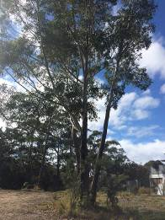
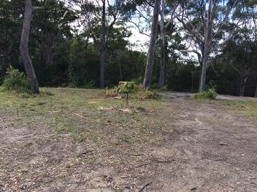

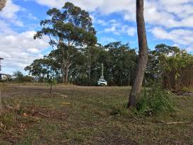
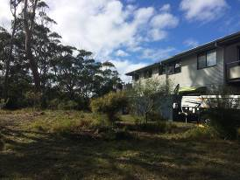

Taking into consideration requirements of a future dwelling on the subject land it is anticipated that a dwelling including ancillary requirements such as asset protection zones could be constructed on the property without impacting on the majority adjoining vegetation in the Lot.

This reclassification will result in the future disposal of the subject land which presently managed as lawn with some scattered trees. The remaining vegetated coastal reserve system comprises approximately 37HA of Council owned and managed land and 151HA of National Parks Estate.

The future disposal of the subject land may result in the potential loss of the several scattered trees in an area of approximately 990m² including future. This future clearing represents an estimated 0.05% of the coastal reserve system, and will involve isolated individual trees not vegetation representative of natural bushland.

It is not considered that the proposal is contrary to this direction.

Direction 2.2 Coastal Management

The objective of this direction is to protect and manage coastal areas of NSW.

This direction applies to land that is within the coastal zone, as defined under the Coastal Management Act 2016 - comprising the coastal wetlands and littoral rainforests area, coastal vulnerability area, coastal environment area and coastal use area - and as identified by the State Environmental Planning Policy (Coastal Management) 2018.

The land is identified in the Coastal Environmental Area and the Coastal Use Area, therefore this direction applies to the subject land.

A planning proposal must include provisions that give effect to and are consistent with:

- the objects of the Coastal Management Act 2016 and the objectives of the relevant coastal management areas;
- the NSW Coastal Management Manual and associated Toolkit;
- NSW Coastal Design Guidelines 2003; and
- any relevant Coastal Management Program that has been certified by the Minister, or any Coastal Zone Management Plan under the Coastal Protection Act 1979 that continues to have effect under clause 4 of Schedule 3 to the Coastal Management Act 2016, that applies to the land.

Although this planning proposal is not specifically referred to in Councils Coastal Zone Management Plan, it is not inconsistent with the provisions of plan.

Overall the planning proposal does not detrimentally impact on the coastal reserve system.

A planning proposal must not rezone land which would enable increased development or more intensive land-use on land:

- within a coastal vulnerability area identified by the State Environmental Planning Policy(Coastal Management) 2018; or

No land has been mapped in the coastal vulnerability area at the time this planning proposal was prepared.

- that has been identified as land affected by a current or future coastal hazard in a local environmental plan or development control plan, or a study or assessment undertaken:

(i) by or on behalf of the relevant planning authority and the planning proposal authority, or

(ii) by or on behalf of a public authority and provided to the relevant planning authority and the planning proposal authority.

The subject land is not mapped in any coastal hazard area.

(6) A planning proposal must not rezone land which would enable increased development or more intensive land-use on land within a coastal wetlands and littoral rainforests area identified by the State Environmental Planning Policy (Coastal Management) 2018.

The subject land is not within a coastal wetlands or littoral rainforest area.

(7) A planning proposal for a Local Environmental Plan may propose to amend the following maps, including increasing or decreasing the land within these maps, under the State Environmental Planning Policy (Coastal Management) 2018:

(a)Coastal wetlands and littoral rainforests area map;
(b)Coastal vulnerability area map;
(c)Coastal environment area map; and
(d)Coastal use area map.

Such a planning proposal must be supported by evidence in a relevant Coastal Management Program that has been certified by the Minister, or by a Coastal Zone Management Plan under the Coastal Protection Act 1979 that continues to have effect under clause 4 of Schedule 3 to the Coastal Management Act 2016.

The planning proposal does not propose to amend any coastal mapping.

The planning proposal is not considered to be contrary to this direction.

Direction 2.3 Heritage Conservation

The objective of this direction is to conserve items, areas, objects and places of environmental heritage significance and indigenous heritage significance. This direction applies when a council prepares a planning proposal.

A planning proposal shall contain provisions that facilitate the conservation of:

a items, places, buildings, works, relics, moveable objects or precincts of environmental heritage significance to an area, in relation to the historical, scientific, cultural, social, archaeological, architectural, natural or aesthetic value of the item, area, object or place, identified in a study of the environmental heritage of the area,
b Aboriginal objects or Aboriginal places that are protected under the National Parks and Wildlife Act 1974, and
c Aboriginal areas, Aboriginal objects, Aboriginal places or landscapes identified by an Aboriginal heritage survey prepared by or on behalf of an Aboriginal Land Council, Aboriginal body or public authority and provided to the council, which identifies the area, object, place or landscape as being of heritage significance to Aboriginal culture and people.

There are locally significant areas to the local aboriginal community in the Valla Beach area however they will not be detrimentally impact by this planning proposal.

The amendments within this planning proposal are not contrary to the requirements of this direction as they will not impact the conservation of the above.

Direction 2.4 Recreation Vehicle Areas

The objective of this direction is to protect sensitive land or land with significant conservation values from adverse impacts from recreation vehicles.

This direction applies when Council prepares a planning proposal. The planning proposal must not enable land to be developed for the purpose of a recreation vehicle area (within the meaning of the Recreation Vehicles Act 1983):

(a) where the land is within an environmental protection zone,
  - (b) where the land comprises a beach or a dune adjacent to or adjoining a beach,
(c) where the land is not within an area or zone referred to in paragraphs (4)(a) or (4)(b) unless the relevant planning authority has taken into consideration:
(i) the provisions of the guidelines entitled Guidelines for Selection, Establishment and Maintenance of Recreation Vehicle Areas, Soil Conservation Service of New South Wales, September, 1985, and
(ii) the provisions of the guidelines entitled Recreation Vehicles Act, 1983, Guidelines for Selection, Design, and Operation of Recreation Vehicle Areas, State Pollution Control Commission, September 1985.

The planning proposal is not contrary to this direction as it does not enable land to be developed for the purpose of a recreation vehicle area.

3 Housing, Infrastructure and Urban Development

Direction 3.1 Residential Zones

The objectives of this direction are:

a to encourage a variety and choice of housing types to provide for existing and future housing needs,
b to make efficient use of existing infrastructure and services and ensure that new housing has appropriate access to infrastructure and services, and
c to minimise the impact of residential development on the environment and resource lands.

This direction applies when a council prepares a planning proposal that affects land within:

a an existing or proposed residential zone (including the alteration of any existing residential zone boundary),
b any other zone in which significant residential development is permitted or proposed to be permitted.

A planning proposal shall include provisions that encourage the provision of housing that will:

a broaden the choice of building types and locations available in the housing market, and
b make more efficient use of existing infrastructure and services, and
c reduce the consumption of land for housing and associated urban development on the urban fringe, and
d be of good design.

A planning proposal shall, in relation to land to which this direction applies:

a contain a requirement that residential development is not permitted until land is adequately serviced (or arrangements satisfactory to the council, or other appropriate authority, have been made to service it), and
b not contain provisions which will reduce the permissible residential density of land.

This direction applies to the planning proposal as it includes the creation of a new residential zone and the alteration to development control standards applying to the land.

The planning proposal is considered to be consistent with this direction by providing opportunities for infill residential development in an area with existing services. The planning proposal will create land development opportunities for residential development that are consistent with the adjoining residential zoned land.

Direction 3.2 Caravan Parks and Manufactured Home Estates

The objectives of this direction are:
(a) to provide for a variety of housing types, and
(b) to provide opportunities for caravan parks and manufactured home estates.

This direction applies to Council when it prepares a planning proposal.

In identifying suitable zones, locations and provisions for caravan parks in a planning proposal, the relevant planning authority must:
(a) retain provisions that permit development for the purposes of a caravan park to be carried out on land, and
(b) retain the zonings of existing caravan parks, or in the case of a new principal LEP zone the land in accordance with an appropriate zone under the Standard Instrument (Local Environmental Plans) Order 2006 that would facilitate the retention of the existing caravan park.

In identifying suitable zones, locations and provisions for manufactured home estates (MHEs) in a planning proposal, the relevant planning authority must:
(a) take into account the categories of land set out in Schedule 2 of SEPP 36 as to where MHEs should not be located,
(b) take into account the principles listed in clause 9 of SEPP 36 (which relevant planning authorities are required to consider when assessing and determining the development and subdivision proposals), and
(c) include provisions that the subdivision of MHEs by long term lease of up to 20 years or under the Community Land Development Act 1989 be permissible with consent.

This direction is relevant to the planning proposal as the existing RE1 Public Recreation Zone permits Caravan Parks or Camping grounds. By Amending the zone to R1 General Residential this land use is no longer permitted on the land.

It is considered any inconsistencies related to this direction are minor and the subject land is not suitable for use as a camping ground due to size and location.

Furthermore, this planning proposal does not seek to identify any suitable zones, locations or provisions for MHEs.

3.3 Home Occupations

The objective of this direction is to encourage the carrying out of low-impact small businesses in dwelling houses. This direction applies when Council prepares a planning proposal.

The direction requires planning proposals to permit home occupations to be carried out in dwelling houses without the need for development consent.

The subject planning proposal does not include any amendments that would alter the existing permissibility to carry out a home occupation without development consent in any land use zones.

3.4 Integrating land Use and Transport

The objective of this direction is to ensure that urban structures, building forms, land use locations, development designs, subdivision and street layouts achieve the following planning objectives:

(a) improving access to housing, jobs and services by walking, cycling and public transport, and

(b) increasing the choice of available transport and reducing dependence on cars, and

(c) reducing travel demand including the number of trips generated by development and the distances travelled, especially by car, and

(d) supporting the efficient and viable operation of public transport services, and

(e) providing for the efficient movement of freight.

This direction applies when Council prepares a planning proposal that will create, alter or remove a zone or a provision relating to urban land, including land zoned for residential, business, industrial, village or tourist purposes.

The direction requires a planning proposal to locate zones for urban purposes and include provisions that give effect to and are consistent with the aims, objectives and principles of:

(a) Improving Transport Choice - Guidelines for planning and development (DUAP 2001), and

(b) The Right Place for Business and Services - Planning Policy (DUAP 2001).

The planning proposal is considered to be consistent with this direction due to its consistency with the provisions of ‘Improving Transport Choice - Guidelines for planning and development’ (the guideline) and ‘The Right Place for Business and Services - Planning Policy’.

The proposal will result in maximising the use of existing infrastructure by encouraging development within existing urban areas.

4 Hazard and Risk

4.1 Acid Sulphate Soil

The subject land is mapped as Class 5 on the NLEP acid sulphate soils map and but is it is above 5m AHD and as such it is considered unlikely that the subject land contains any potential Acid sulphate soils. This direction is not applicable to the planning proposal.

4.3 Flood Prone Land

Part of Lot 45 DP228703 is recognised as being flood affected in a 1%AEP flood event and a PMF flood event associated with Deep Creek. However, the flood affected land is a gully located over 60m from the subject land to be reclassified as part of this planning proposal.

4.4 Planning for Bushfire Protection

The objectives of this direction are:

(a) to protect life, property and the environment from bush fire hazards, by discouraging the establishment of incompatible land uses in bush fire prone areas, and

(b) to encourage sound management of bush fire prone areas.

This direction applies when Council prepares a planning proposal that will affect, or is in proximity to land mapped as bushfire prone land.

The direction requires Council to consult with the Commissioner of the NSW Rural Fire Service following receipt of a gateway determination from the Minister and take into account any comments made. It also requires the planning proposal to:

(a) have regard to Planning for Bushfire Protection 2006,

(b) introduce controls that avoid placing inappropriate developments in hazardous areas, and

(c) ensure that bushfire hazard reduction is not prohibited within the APZ.

The planning proposal is considered to be consistent with this direction because:
- Part of the subject land is identified as being bushfire prone land;
- Consultation with the Commissioner of the NSW Rural Fire Service will occur once gateway approval has been received from the Minister.
- All future development resulting from the amendments will be capable of being compliant with the aims and objectives of Planning for Bushfire Protection 2006.
- It will not create potential for new inappropriate developments in hazardous areas.
- Will not prohibit hazard reduction.

5 Regional Planning

Direction 5.10 Implementation of Regional Plans

The objective of this direction is to give legal effect to the vision, land use strategy, goals, directions and actions contained in Regional Plans. This direction applies to land to which a Regional Plan has been released by the Minister for Planning.

This direction applies when Council prepares a planning proposal. Planning proposals must be consistent with a Regional Plan released by the Minister for Planning.

As outlined earlier, this planning proposal is considered to be consistent with the North Coast Regional Plan 2036 (the plan) largely as it will contribute to housing supply and choice which will assist affordability.

6 Local Plan Making

Direction 6.1 Approval and Referral Requirements

The objective of this direction is to ensure that LEP provisions encourage the efficient and appropriate assessment of development.

A planning proposal shall:

a minimise the inclusion of provisions that require the concurrence, consultation or referral of development applications to a Minister or public authority, and
b not contain provisions requiring concurrence, consultation or referral of a Minister or public authority unless the council has obtained the approval of:
i the appropriate Minister or public authority, and
ii the Director-General of the Department of Planning (or an officer of the Department nominated by the Director-General),
prior to a certificate under section 65 of the Act being issued, and
c not identify development as designated development unless the council:
i can satisfy the Director-General of the Department of Planning (or an officer of the Department nominated by the Director-General) that the class of development is likely to have a significant impact on the environment, and
ii has obtained the approval of the Director-General of the Department of Planning (or an officer of the Department nominated by the Director-General) prior to a certificate being issued under section 65 of the Environmental Planning and Assessment Act 1979.

This Planning Proposal does not require the implementation of any concurrence provisions. The planning proposal is consistent with this direction.

Direction 6.2 Reserving Land for Public Purposes

The objectives of this direction are:

a to facilitate the provision of public services and facilities by reserving land for public purposes, and
b to facilitate the removal of reservations of land for public purposes where the land is no longer required for acquisition.

A planning proposal shall not create, alter or reduce existing zonings or reservations of land for public purposes without the approval of the relevant public authority and the Director-General of the Department of Planning (or an officer of the Department nominated by the Director-General).

When a Minister or public authority requests a council to reserve land for a public purpose in a planning proposal and the land would be required to be acquired under Division 3 of Part 2 of the Land Acquisition (Just Terms Compensation) Act 1991, the council shall:

a reserve the land in accordance with the request, and
b include the land in a zone appropriate to its intended future use or a zone advised by the Director-General of the Department of Planning (or an officer of the Department nominated by the Director-General), and
c identify the relevant acquiring authority for the land.

When a Minister or public authority requests a council to include provisions in a planning proposal relating to the use of any land reserved for a public purpose before that land is acquired, the council shall:

a include the requested provisions, or
b take such other action as advised by the Director-General of the Department of Planning (or an officer of the Department nominated by the Director-General) with respect to the use of the land before it is acquired.

When a Minister or public authority requests a council to include provisions in a planning proposal to rezone and/or remove a reservation of any land that is reserved for public purposes because the land is no longer designated by that public authority for acquisition, the council shall rezone and/or remove the relevant reservation in accordance with the request.

This Planning Proposal will require the approval of the director general and therefore is consistent with this direction.

Direction 6.3 Site Specific Provisions

The objective of this direction is to discourage unnecessarily restrictive site specific planning controls. It requires a planning proposal that will amend another environmental planning instrument in order to allow a particular development proposal to be carried out to either:
- Allow that land use to be carried out in the zone the land is situated on, or
- Rezone the site to an existing zone already applying in the environmental planning instrument that allows that land use without imposing any development standards or requirements in addition to those already contained in that zone, or
- Allow that land use on the relevant land without imposing any development standards or requirements in addition to those already contained in the principle environmental planning instrument being amended.

No site specific controls area proposed as part of this planning proposal. The proposal is consistent with this direction as there will be no development standards or requirements imposed in addition to those already contained in the existing LEP.

Section C – Environmental, social and economic impact

7 Is there any likelihood that critical habitat or threatened species, populations or ecological communities, or their habitats, will be adversely affected as a result of the proposal?

It is not considered that the proposal will have any significant effects on threatened species, populations, communities or their habitats. The site is largely modified and managed as mown lawn. Some scattered trees may require removal as part of future development on the subject land;
8 Are there any other likely environmental effects as a result of the planning proposal and how are they proposed to be managed?

Given the disturbed/modified nature of the land the subject of this planning proposal and the existing planning controls applicable to future development on the land, it is not considered that there will be any other likely environmental effects as a result of the planning proposal.

9 Has the planning proposal adequately addressed any social and economic effects?

Council Open Space Strategy identifies that Council as a sufficient supply of open space in the shire and that focus should be on enhancing existing facilities not acquiring new land (other than as required by new developments). The following extracts are taken directly from Council’s Community Facilities and Open Space Needs Strategy (2015) (CFOSNS).
It is highlighted in the strategy that “most public open space should be retained” as the open spaces of the LGA define the character of the shire through the provision of natural areas, active and passive recreational uses and contribute to the general liveability of the shire.

Whilst the broader significance of the public reserve linked to this proposal is unquestionable, the subject land is presently a space that contributes little significance to the local/ broader community, local biodiversity, amenity or connectivity in Valla Beach Area.

The subject land is:

- largely managed as lawn;
- has limited recreational value as open space;
- has limited viability as a potential natural area through restoration or natural regeneration due to:
  - its potential to contribute bushfire risk on adjoining urban land; and
  - Historically Council has received several requests to remove juvenile and mature trees from the adjoining Lot that have been perceived as a potential risk to life or property.
- It adjoins an existing footpath network on the eastern side of Ocean View Drive.

As identified in the CFOSNS the Valla and Valla Beach Community is defined by the following open space provision in comparison to other areas townships in the shire:

Township | Population | CL Provision | Ha/1,000* | % of CL | Pop’n %
Nambucca Heads | 6,222 | 209.7 ha | 33.7 ha | 37.0% | 33.4%
Macksville (incl Macksville North) | 2,567 | 57.7 ha | 22.5 ha | 10.2% | 13.8%
Bowraville | 1,208 | 67.9 ha | 56.2 ha | 12.0% | 6.5%
Valla Beach and Valla | 1,200 | 42.6 ha | 35.5 ha | 7.5% | 6.4%
Scotts Head | 821 | 19.1 ha | 23.3 ha | 3.4% | 4.4%
Rural, Non-Urban, Other | 6,626 | 169.4 ha | 25.6 ha | 29.9% | 35.5%
TOTAL | 18,644 | 566.4 ha | 30.4 ha* | 100% | 100%

Valla Beach is characterised by the following major open spaces or reserve areas:

- Valla Nature Reserve (NPWS)
- Jagun Nature Reserve (NPWS)
- Anderson Park (Council)
- Lions Reserve
- Coastal Reserves;

A plan showing all open space in the Valla Beach area is provided as attachment 2. The total area of Council owned or managed land is Valla Beach is approximately 46HA which includes the subject land. Of this approximately 0.7HA is operational land for pump stations and similar uses. An important feature of the Valla Beach locality and its available Open Space is the National Park Reserves Jagun and Valla which total 151HA approximately.

The total area of these no-operational open space areas in Valla Beach is approximately 196HA. It is important to note that this figure excludes recreational opportunities offered by large portions of the Beach and Deep Creek which are major key contributor to the character and liveability of the Valla Beach locality.

Should Council progress with this planning proposal it will reduce the amount of open space by approximately 1300m² or 0.06% (inclusive of National Park Reserve) or 0.2% (based on Council owned or managed land). This is not considered a significant reduction in the amount of non-operational open space. In terms of alternative opportunities for other open space use in other parts of Valla it is unlikely that this relatively small section of land will ever have a functional value.

The physical character of the subject land is not an accurate reflection of its current categorisation as Natural Area – Bushland.

Section D – State and Commonwealth Interests

10 Is there adequate public infrastructure for the planning proposal?

Yes. All land the subject of this planning proposal with future development potential is currently adequately provisioned with the necessary public infrastructure.

11 What are the views of State and Commonwealth public authorities consulted in accordance with the gateway determination?

Government authorities have not been formally involved in this planning proposal as it is yet to receive gateway approval.

Part 4 Mapping

It is proposed to amend the Part Lot Reclassification Maps, Land Zoning, Minimum Lot Size, Floor Space Ratio, and Building Heights maps. Draft maps prepared for exhibition purposes have been included within the attachments of this planning proposal.

Part 5 Community Consultation

It is intended to undertake community consultation by way of an advertisement in the local newspaper and Councils website and notification to adjoining landowners advising of the planning proposal and the opportunity to make a submission. It is intended to advertise the planning proposal for 28 days.

Section 29 of the Act provides that a council must arrange a public hearing under section 57 of the Environmental Planning and Assessment Act 1979 in respect of a planning proposal to reclassify community land as operational land. The public hearing has to be conducted by a person independent of Council.

The process of preparing a local environmental plan incorporating a public hearing conducted by a person independent of Council will provide many opportunities for the recommendation in this report to be reviewed and the process discontinued.

Part 6 Project Timeline

August 2019 Gateway determination issued by Department of Planning & Environment
August/ September 2019 Consultation with government agencies
October 2019 Public exhibition, public hearing and analysis of public submissions
November 2019 Preparation of Council report
January/ February 2020 Endorsed planning proposal submitted to Department of Planning and Environment for finalisation

Attachment 1
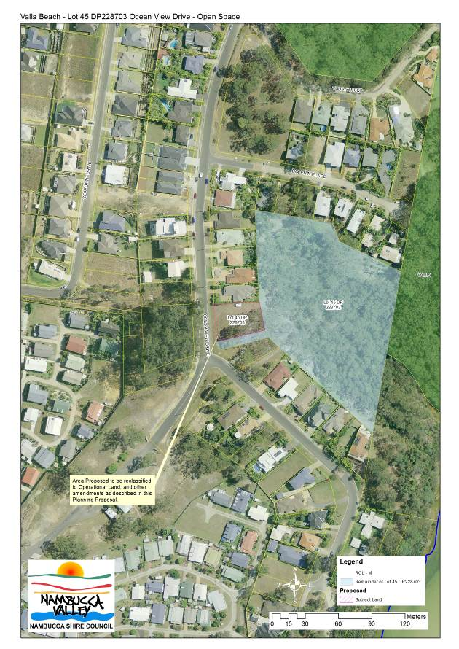
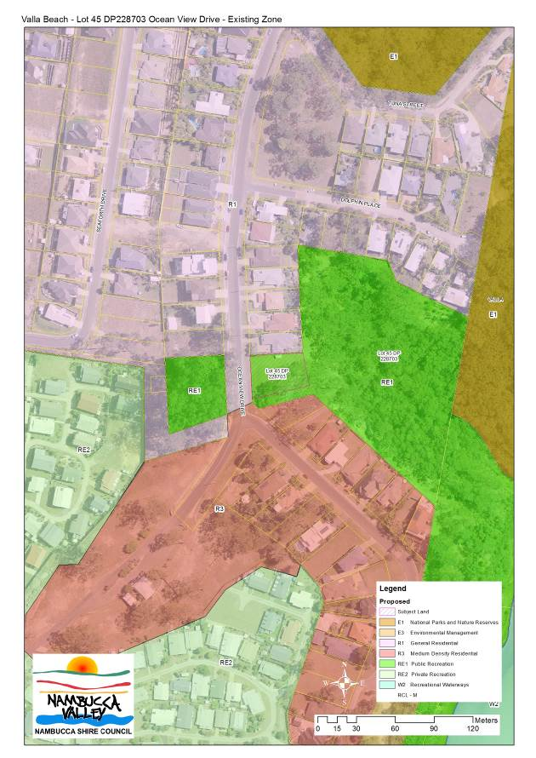
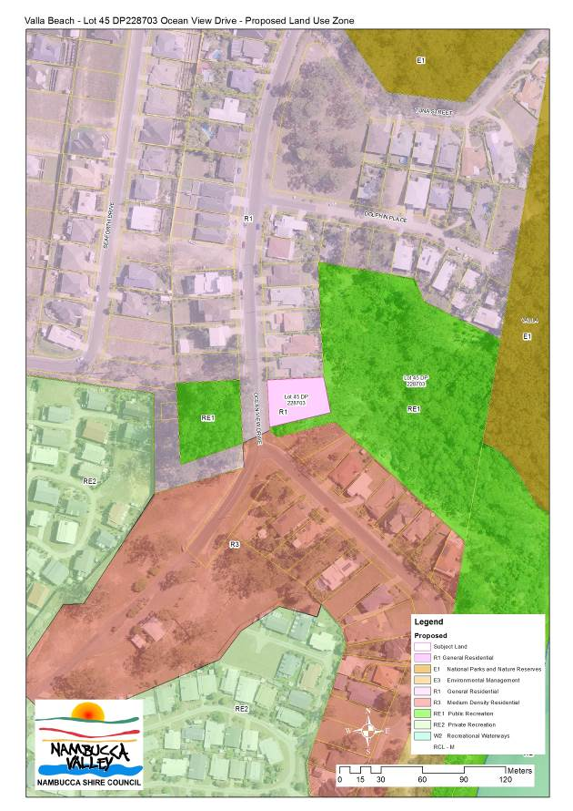
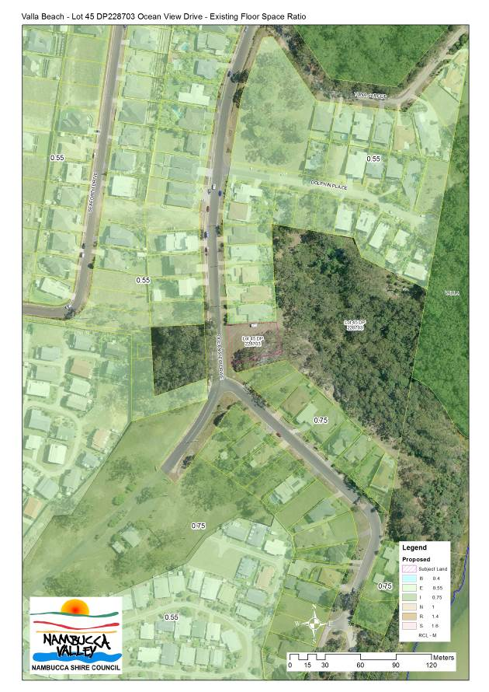
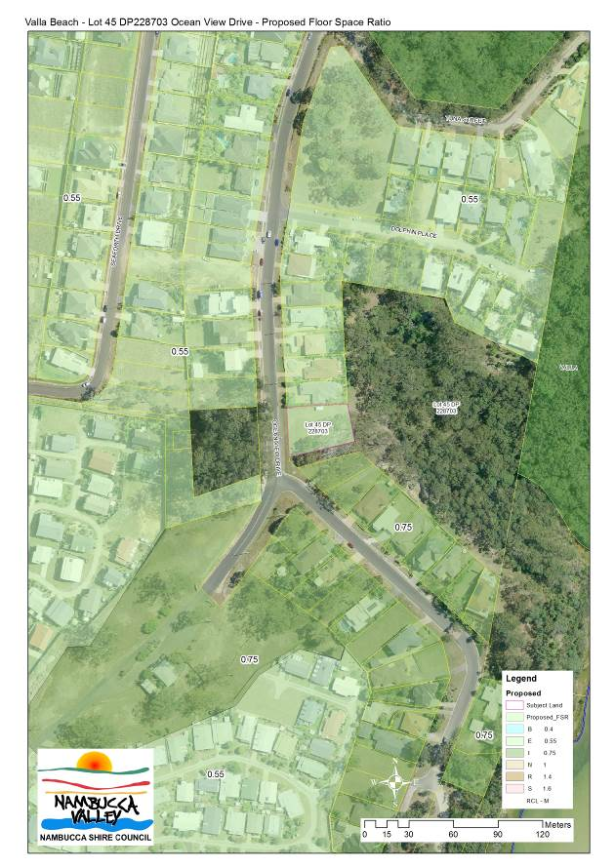
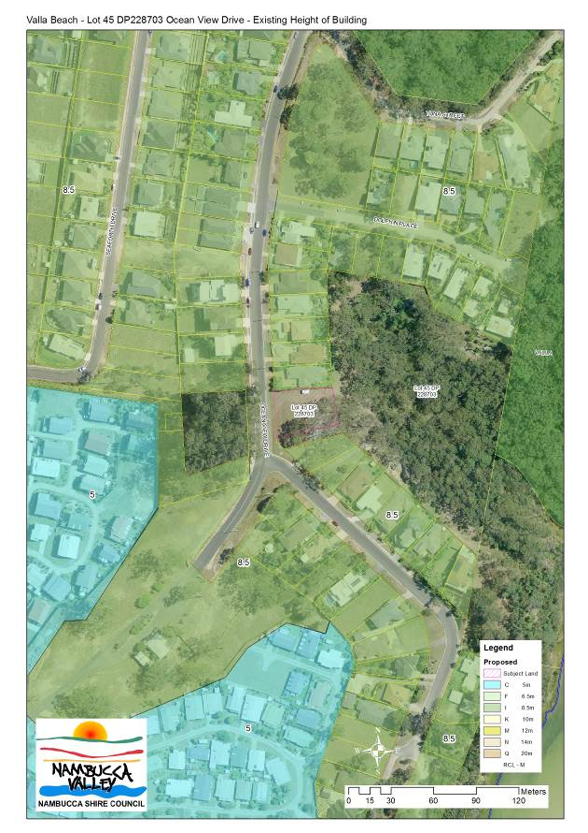
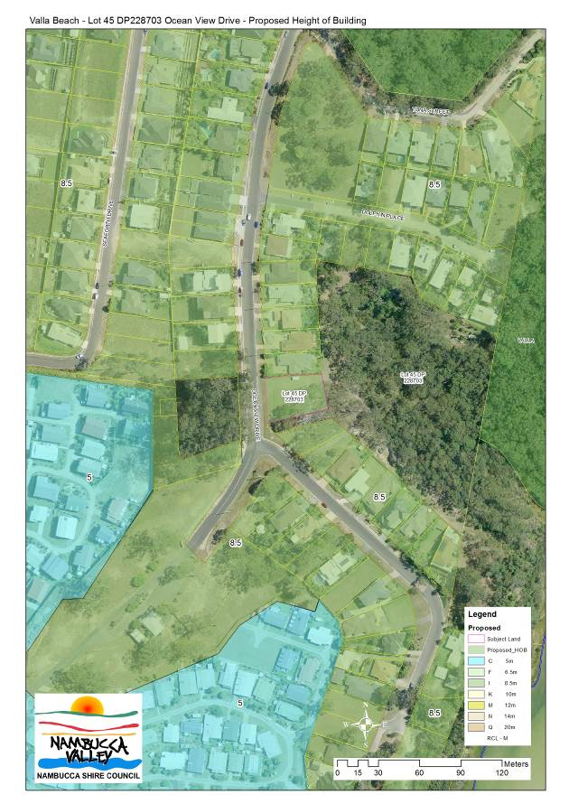
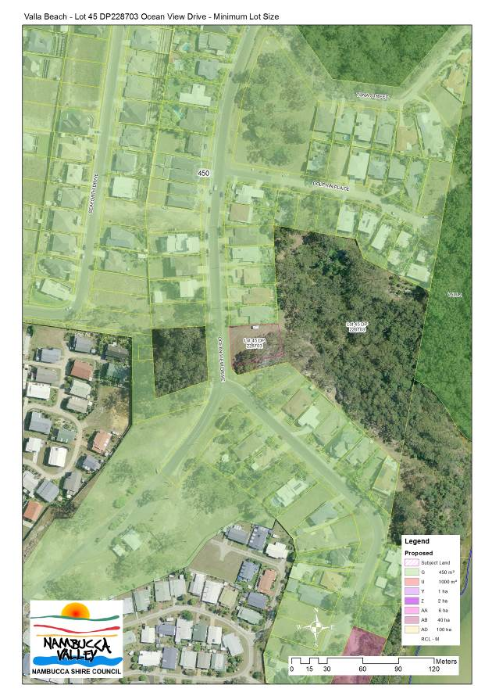
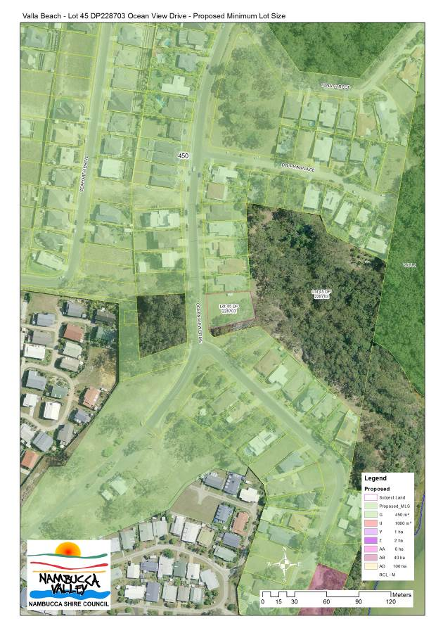
Attachment 2

